AP Physics Jeopardy User Manual
By Seth Baum
November 23, 2007

Introduction

AP Physics Jeopardy is based on the popular television game show Jeopardy. It is designed as a group study/review activity for AP Physics students. It consists of a series of HTML files that should run on most internet web browsers. The files can be downloaded to a computer’s hard disk space so that the game can be played where there is no internet access. The game works best when it can be projected on a screen or wall so that a larger group of students can play, but those without access to such equipment may find other means of making the game work.

Authors

The game was designed by Seth Baum while a PhD student in electrical engineering at Northeastern University and a National Science Foundation GK-12 Fellow. The game was made for the AP Physics class at the John D. O'Bryant School of Math & Science in Boston, MA, USA, with the assistance of teacher Steve Fernandez. As of November 23, 2007, the game is available for free download at
http://sethbaum.com/education/games/jeopardy/APphysics/

To Begin Play

Open the file “index.html” in the folder “play”.

Making New Games Or Game Rounds

The current version of the game is customized as a general, end-of-year review for AP Physics students. However, the Jeopardy format can be adapted to many other classes or other scenarios. We encourage creative use of the code we have developed. All we ask in return is that you inform us of what you use it for and provide us with your modified versions, so we can continue to serve as a central resource for the Jeopardy series.

New versions can be made by changing the content of an old version. This can be done with webpage editors such as Dreamweaver or with a simple text editor such as Notepad. Here are basic instructions for making new versions with Notepad using Microsoft Windows XP.

- To open a file in notepad, right-click on it and select “Open With”. If Notepad appears as an option, click on Notepad. Otherwise, click on “Choose Program…” and select Notepad from the list that appears.

- The file that opens up is the webpage’s html code. By changing the html code, you change the appearance of the webpage. Below are instructions for updating each page you’ll need to adjust to make a new game version.

Game Selection Page

The game selection page is the first page you visit. It looks like:

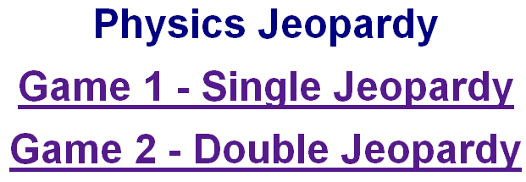

It is the file “index.html” in the folder “play”:
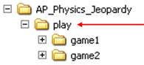

The portions of this file you are likely to want to change are underlined in red below. If you create more games (Triple Jeopardy?) then you will want to add additional game selection lines and change the portions underlined in blue below.
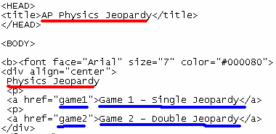

Game Board Page

The game board page is used to choose question/answers. Each game (Single Jeopardy & Double Jeopardy) has its own board page. The Single Jeopardy page looks like:

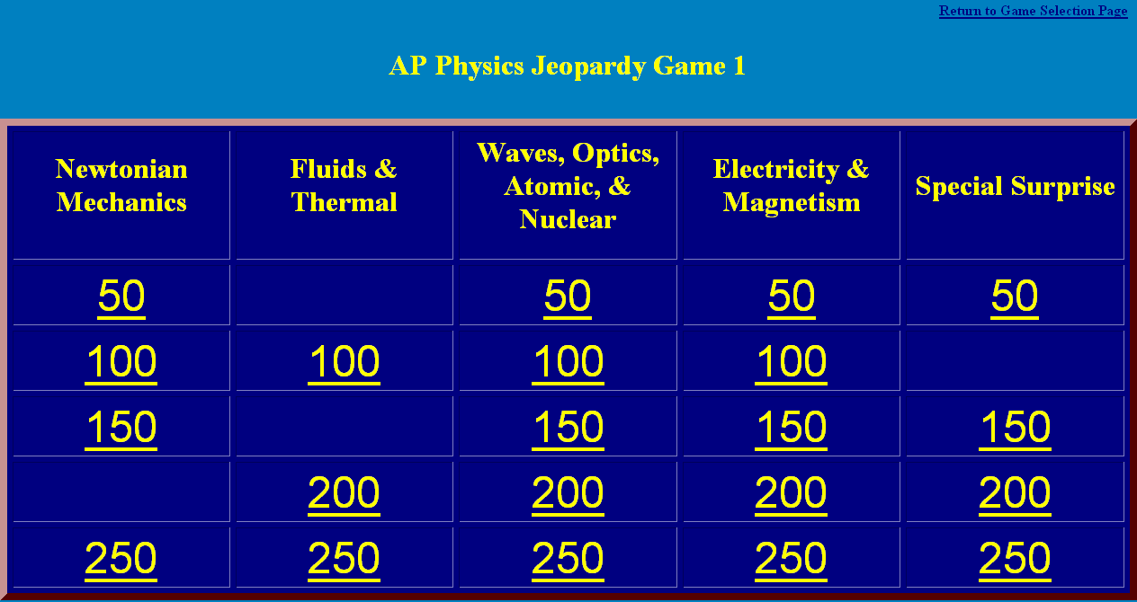

The game board pages are the files “index.html” in the folders “game1” & “game2”:
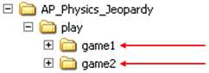

The portions of this file you are likely to want to change are underlined/circled in red below.
…
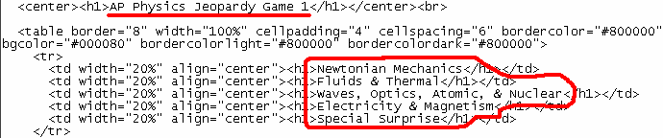

Answer Page

The answer page displays the answer which the players must guess the question for. Each game has 25 answer pages: 5 category columns, each with 5 point values. The page looks like:
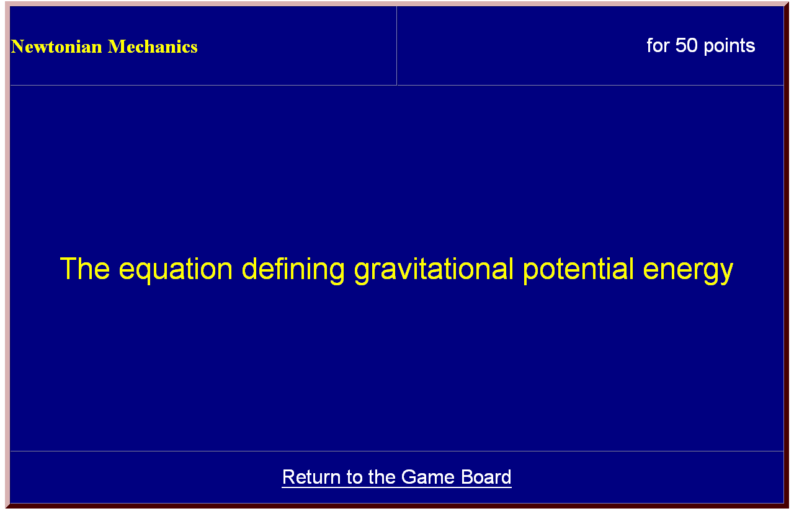

The answer pages are the files “050_a.html”, “100_a.html”, etc. in the folders “single_columna”, “single_columnb”, etc:
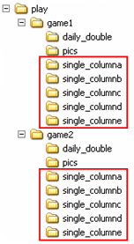

The Daily Double answer pages (found in the “daily_double” folder) are similar.

The portions of this file you are likely to want to change are underlined in red below.
…
…

